A GUIDE TO THE INSTALLATION AND CONFIGURATION OF WIREGUARD VPN

A VPN is a secure/encrypt tunnel between your device and a secure Server, then sending your traffic through it.

A Tunnel is a medium created between two devices/nodes through which traffic flow to and from. A Secure Tunnel is a Tunnel with only a secure data/traffic exchange between the nodes.

The driving force (ie Protocol) creating each encrypted tunnel, which determines that tunnel’s shape and sizes. WireGuard is just one of the several different types of protocols used to create these tunnels.

WireGuard is a communication protocol and free and open-source software that implements encrypted virtual private network (VPN), and was designed with the goal of easy use, high speed performance, and low attack surface. WireGuard cryptographic primitives may be faster and it is built into the Linux Kernel.

The below are the procedure for the installation and configuration of a WireGuard VPN between a VPN Server and a Client.

At the VPN Server
Installation Requirement
- Any OS
- Update or Upgrade the Package Management
- Open port 51820 (WireGuard VPN default)

Installation Steps:
Step 0 -: Change the hostname to wgserver
sudo hostnamectl set-hostname wgserver

Step 1 -: Update or Upgrade the package management
sudo apt-get update -y or sudo apt-get upgrade -y

Step 2 -: Install iptables, net-tools
sudo apt-get install iptables net-tools -y

Step 3 -: Install WireGuard VPN Software on the System
sudo apt-get install wireguard -y # Ubuntu
sudo yum install wireguard-tools -y # Redhat

Step 4a -: Switch to root user profile.
sudo su -
Step 4b -: Go to /etc/wireguard WireGurad directory
cd /etc/wireguard/

Step 5 -: Enable IP Forwarding to route packets between VPN Clients and the Internet
# Check IP forward on ipv4. If result is 0 set it to 1
cat /proc/sys/net/ipv4/ip_forward

sudo vi /etc/sysctl.conf # View and Edit the System Config. file
uncomment this line …… net.ipv4.ip_forward=1
net.ipv4.ip_forward = 1 # or add this to the file
:wq! # To save and quite
sudo sysctl -p # View the set value or uncomment value and reset the system.

Step 6a -: Create a private and public key pair for the WireGuard Server
# generate private key through which a publickey is created
wg genkey | tee privatekey | wg pubkey > publickey

Step 6b -: Show and Copy Private key
cat privatekey
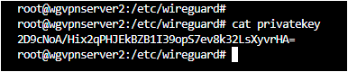

Step 7 -: Create a new config file called wgs0.conf # ls to list content
touch wgs0.conf
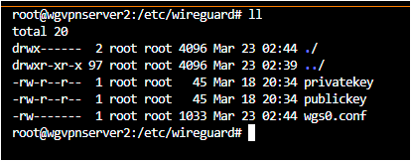

Step 8 -: Open wgs0.conf and configure the Network Interface
vi wgs0.conf
++++++++++++++++++++++++++++++++++++++++++++++++++++++++++++++++++++++++++++++
[Interface]
## A privatekey of the Server you copied ( cat /etc/wireguard/privatekey )
Privatekey = sDMJiu ……. LhWUY=
## Address: A private IP address for wg0 interface
Address = 120.0.0.1/32
## Saving Configuration File
SaveConfig = true

## NOTE the enp0s9 must be the public Network Interface of the Server.
## Some distors are of name eth0
## The PostUp will run when the WG Server starts the Virtual VPN tunnel
PostUp = iptables -A FORWARD -i wg0 -j ACCEPT
PostUP = iptables -t nat -A POSTROUTING -o enp0s9 -j MASQUERADE

## The PostDown rules run when the WG Server stops the Virtual VPN tunnel
PostDown = iptables -D FORWARD -i wg0 -j ACCEPT
PostDown = iptables -t nat -D POSTROUTING -o enp0s9 -j MASQUERADE

## Specify the listening port of WireGuard. This is the defaut.
ListenPort = 51820

## After the Installation and Configuration at the Client side
## we update the Network Interface at the Server side
## with below details for each peer(client)
[Peer]
## A public key of the Client1 ( cat /etc/wireguard/publickey )
Publickey = gF98uIOMNe ……..sDMJiu=
## The assign IP address of Client1 Network Interface
AllowedIPs = 120.0.0.2/32

[Peer]
## A public key of the Client2 ( cat /etc/wireguard/publickey )
Publickey = IOMNegFsDM ……..Jiu98u=
## The assign IP address of Client2 Network Interface
AllowedIPs = 120.0.0.3/32

:wq! # To save and quit
++++++++++++++++++++++++++++++++++++++++++++++++++++++++++++++++++++++++++++++
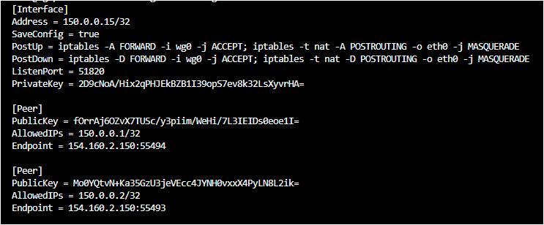
The Endpoint of the Peer are updated accordingly after connection is established.

## Enable the Server to listen on the WG set default port via 51820 UDP
## You could set any other port to listen on this Server
Step 9 -: Configure UFW firewall to open WireGuard VPN Server
sudo ufw status # Check status of the UFW
sudo ufw allow 51820/udp ## Open the port 51820 on UDP
sudo ufw enable ## To enable ufw
sudo ufw disable ## To disable ufw

Step 10a-: Bring up the Network Interface - wgs0
wg-quick up wgs0 # Start the wg0 Interface
wg or sudo wg # Display the Interface Details
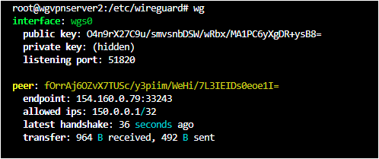

Step 10b- : Put down the Network Interface - wgs0
wg-quick down wgs0 # To put down wg0 Interface
ip link or sudo ip a show wgs0 # Show the Network Interfaces on the Host.

Step 11 -: Check the status. Start and Enable WireGuard Sever.
## NOTE: PUT DOWN THE NETWORK INTERFACE BEFORE EDITTING IT
systemctl status wg-quick@wgs0 # Check the status of wg-quick on wgs0
systemctl start wg-quick@wgs0.service # Start wg-quick on wgs0 service
systemctl enable wg-quick@wgs0.service # Enable wg-quick on wgs0 service
systemctl restart wg-quick@wgs0.service # Restart the wg-quick on wgs0 service
systemctl stop wg-quick@wgs0.service # Stop the wq-quick on wgs0 service

At a VPN Client
Installation Requirement
- Any OS
- Update or Upgrade the Package Management

Installation Steps:
Step 0 -: Change the hostname to wgclient1
sudo hostnamectl set-hostname wgclient1

Step 1 -: Update or Upgrade the package management
sudo apt-get update -y or sudo apt-get upgrade -y

Step 2 -: Install iptables, net-tools
sudo apt-get install iptables net-tools -y

Step 3 -: Install WireGuard VPN Software on the System
sudo apt-get install wireguard -y # Ubuntu
sudo yum install wireguard-tools -y # Redhat

Step 4a -: Switch to root user profile.
sudo su -
Step 4b -: Go to /etc/wireguard WireGurad directory
cd /etc/wireguard/

Step 5a -: Create a private and public key pair for the WireGuard Client
# generate private key through which a publickey is created
wg genkey | tee privatekey | wg pubkey > publickey # ls to list content

Step 5b -: Show and Copy Private key
cat privatekey


Step 6 -: Create a new config file called wgs0.conf
touch wgs0.conf

Step 7 -: Open wgs0.conf and configure the Network Interface
vi wgs0.conf
******************************************************************************
[Interface]
## A privatekey of the Client you copied ( cat /etc/wireguard/privatekey )
Privatekey = sDMJiu ……. LhWUY=
## Address: A private IP address for wg0 interface
Address = 120.0.0.2/32
## Saving Configuration File
SaveConfig = true

## Below tell the WG Client to connect or speak to the WG Server….
[Peer]
## A public key of the Server ( cat /etc/wireguard/publickey )
Publickey = gF98uIOMNe ……..sDMJiu=

## Public IP address of the WireGuard Server [on the Server ip addr show]
## also the its ListenPort
##NOTE: On the WireGuard Server side, we need to set 'net.ipv4.ip_forward=1'
Endpoint = 192.168.10.1:51820

## 0.0.0.0/0, ::/0 ==> All traffic of (IPv4 & IPv6) route to the Server.
AllowedIPs = 0.0.0.0/0, ::/0
## We can specify specific IPs to pass through from Client to Server
## AllowedIPs = 10.10.10.230/32, 120.3.45.9/32, 120.34.50.30/24

## Keepalive time (in seconds)
Persistentkeepalive = 25 # 25 seconds

:wq! # To save and quit
*************************************************************************************
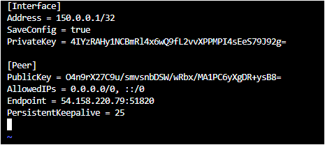

Step 8a-: Bring up the Network Interface - wgs0
wg-quick up wgs0 # Start the wgs0 Interface
wg or sudo wg # Display the Interface Details
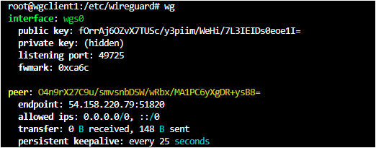

Step 8b- : Put down the Network Interface - wgs0
wg-quick down wgs0 # To put down wg0 Interface
ip link or sudo ip a show wgs0 # Show the Network Interfaces on the Host.

Step 9 -: Check the status. Start and Enable WireGuard Sever.
## NOTE: PUT DOWN THE NETWORK INTERFACE BEFORE EDITTING IT
systemctl status wg-quick@wgs0 # Check the status of wg-quick on wgs0
systemctl start wg-quick@wgs0.service # Start wg-quick on wgs0 service
systemctl enable wg-quick@wgs0.service # Enable wg-quick on wgs0 service
systemctl restart wg-quick@wgs0.service # Restart the wg-quick on wgs0 service
systemctl stop wg-quick@wgs0.service # Stop the wq-quick on wgs0 service

At both ends of the Server and Clients, run command ‘ wg ’ or ‘ wg show ‘ ; if the feedback of its comes as the output with handshake interface means connection/a secure tunnel has been established between nodes.

WireGuard VPN Server WireGuard VPN Client
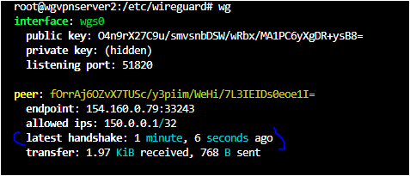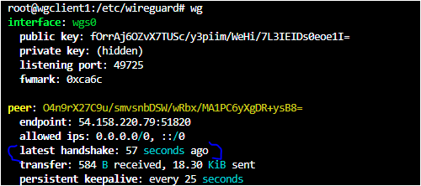

* Ping respective ips at either ends to confirm the connectivity with each other. * If ping result is responding
then the Server and Clients then a VPN has been created between ends using WireGuard Protocol.

Thank YOU.

